Q1) W.A.P to print welcome programming ?
CODE:
publicclass Welcome
{
publicstaticvoid main(String[] args)
{
System.out.println("Welcome to java programming!!!");
}

}
O/P:
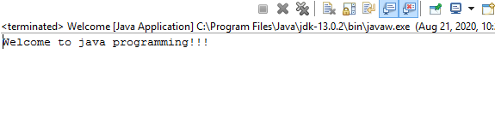

Q2) W.A.P to implement all types of constructor in java ?
CODE :
public class Box
{
/*Note : When there is no constructor defined in the class by programmer ,
compiler implicitly provides a default constructor */
private int l ;
private int b ;
private int h ;
public Box() // constructor1 No argumented constructor
{
l = 10;
b = 8;
h = 4;
System.out.println("Inside No Argumented constructor : ");
}
public Box(int L , int B, int H) //constructor2 parameterized constructor
{
l = L;
b = B;
h = H;
System.out.println("\nInside Parametrized constructor : ");
}
void display()
{
System.out.println("Length of box === "+l);
System.out.println("Breadth of box === "+b);
System.out.println("Height of constructor === "+h);

}
public static void main(String[] args)
{
Box b1 = new Box(); //Creating first object
System.out.println();
b1.display();

Box b2 = new Box(20,15,5); //Creating second object
System.out.println();
b2.display();
}
}

O/P:
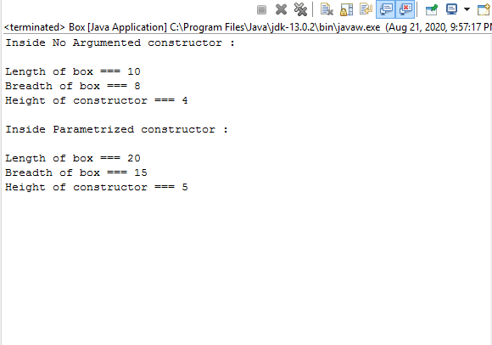

Q3) W.A.P to implement constructor overloading ?
CODE :
publicclass Student
{
intRoll;
String Name;
double Marks;

Student(int R, String N, double M) // Constructor 1
{
Roll = R;
Name = N;
Marks = M;
}

Student(String N ,double M,int R) // Constructor 2
{
Roll = R;
Name = N;
Marks = M;
}

void Display()
{
System.out.print("\n\t" + Roll+"\t" + Name+"\t" + Marks);
}

publicstaticvoid main(String[] args)
{
Student S1 = new Student(1,"Kumar",78.53); // Statement 2
Student S2 = new Student("Sumit",89.42,2); // Statement 1

System.out.print("\n\tRoll\tName\tMarks\n");

S1.Display();
S2.Display();
}
}

O/P:
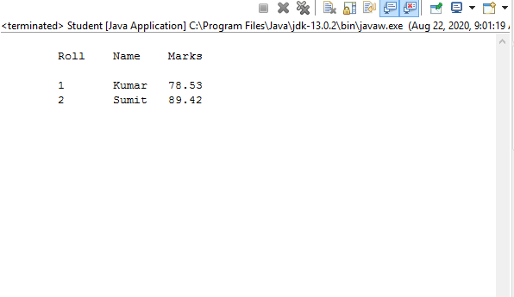

Q4. Write a program to show single level inheritance in java.
Source Code:
class Animal{
void eat(){System.out.println("eating...");}
}
class Dog extends Animal{
void bark(){System.out.println("barking...");}
}
classSingleInheritance{
public static void main(String args[]){
Dog d=new Dog();
d.bark();
d.eat();
}}
Output:
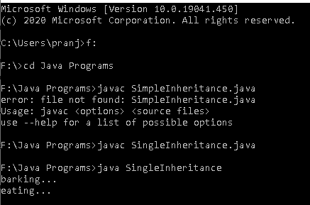

Q5. Write a program to show Multilevel Inheritance in java.
Source Code:
class Animal{
void eat(){
System.out.println("eating...");
}
}
class Dog extends Animal{
void bark(){
System.out.println("barking...");
}
}
classBabyDog extends Dog{
void weep(){System.out.println("weeping...");}
}
classMultiLevel{
public static void main(String args[]){
BabyDog d=new BabyDog();
d.weep();
d.bark();
d.eat();
}}

OUTPUT:
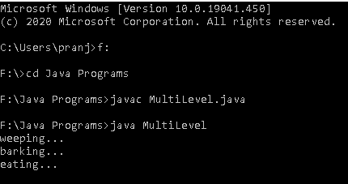

Q6. Write a program to show Hierarchical Inheritance in java.

Source Code:

class Animal{

void eat(){System.out.println("eating...");}

}

class Dog extends Animal{

void bark(){System.out.println("barking...");}

}

class Cat extends Animal{

void meow(){System.out.println("meowing...");}

}

class Inheritance3{

public static void main(String args[]){

Cat c=new Cat();

c.meow();

c.eat();

}}

OUTPUT:
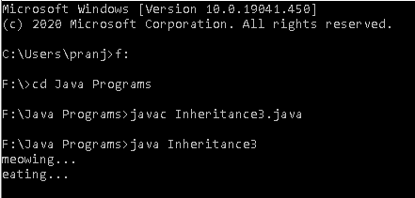

Q7. Write a program to show Multiple Inheritance in java.
Source Code:
interfaceAnimalEat {
void eat();
}
interfaceAnimalTravel {
void travel();
}
class Animal implements AnimalEat, AnimalTravel {
public void eat() {
System.out.println("Animal is eating");
}
public void travel() {
System.out.println("Animal is travelling");
}
}
public class Multiple {
public static void main(String args[]) {
Animal a = new Animal();
a.eat();
a.travel();
}
}

OUTPUT:
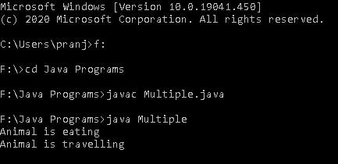

Q8. Write a program to show Hybrid Inheritance in java.
Source Code:
classGradFater {
public void land() {
System.out.println("GradFater's land");
}
}
class Father extends GradFater {
public void home() {
System.out.println("Father's home");
}
public void Car() {
System.out.println("Father's Car");
}
}
class Son extends Father {
public Son() {
System.out.println("Son...");
}
public void mobile() {
System.out.println("Son's mobile");
}
}
class Daughter extends Father {
public Daughter() {
System.out.println("Daughter...");
}
public void purse() {
System.out.println("Daughter's purse");
}
}
public class HybridInheritance {
public static void main(String[] args) {
Son s = new Son();
s.land();
s.Car();
s.home();
s.mobile();
Daughter d = new Daughter();
d.land();
d.Car();
d.home();
d.purse();
}
}

OUTPUT:
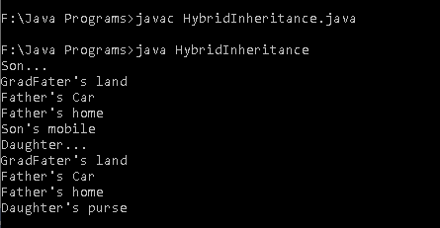

Q9.Write a program to implement command line argument.
SOURCE CODE:
public class CommandLine{
public static void main(String[] args)
{
for(inti=0;i<args.length;i++)
{
System.out.println(args[i]);
}
}
}
OUTPUT:
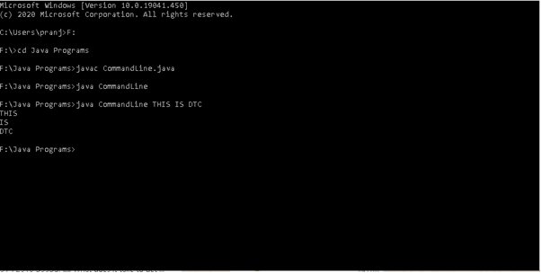

Q10. Write a program to implement java explicit type casting.
SOURCE CODE:
class Explicit {
public static void main(String args[]) {
double d = 500.4;
long l = (long) d;
inti = (int) d;
byte b = (byte) d;

System.out.println("Value in long: " + l);
System.out.println("Value in int: " + d);
System.out.println("Value in Byte: " + b);
}
}
OUTPUT:
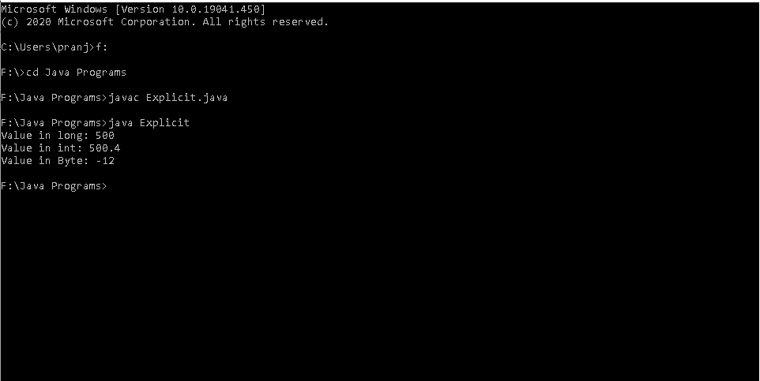

Q11.Write a program to implement java implicit type casting.
SOURCE CODE:
class Implicit {
public static void main(String args[]) {
int b = 150;
long l = b;
double d = b;
System.out.println("Long value is " + l);
System.out.println("Double value is " + d);
}
}
OUTPUT:
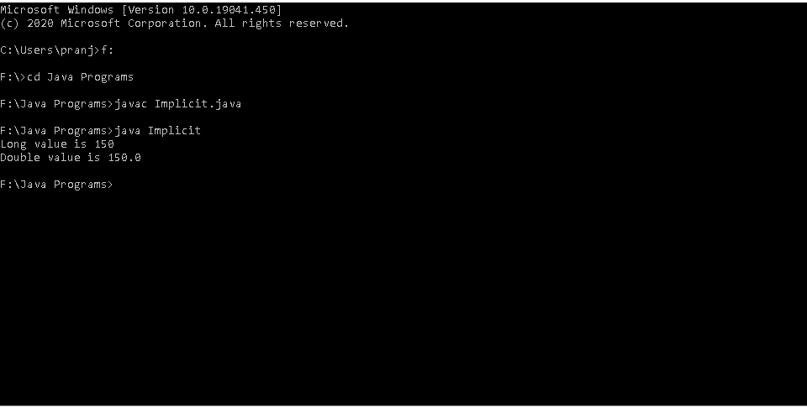

Q12. Write a program to implement break and switch in java.
SOURCE CODE:
public class SwitchCase {

public static void main(String args[]){
inti=2;
switch(i)
{
case 1:
System.out.println("Case1 ");
break;
case 2:
System.out.println("Case2 ");
break;
case 3:
System.out.println("Case3 ");
break;
case 4:
System.out.println("Case4 ");
break;
default:
System.out.println("Default ");
}
}
}
OUTPUT:
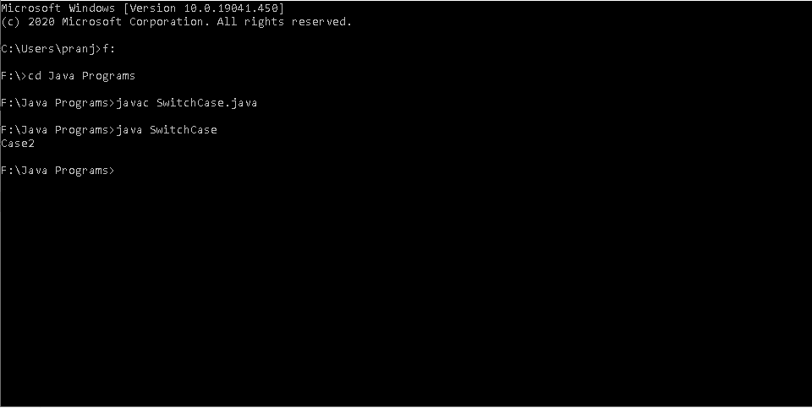

Q8public class BrAndCon
{

public static void main(String[] args)
{ System.out.println("Answer using break keyword is ");
for (int i = 0; i < 10; i++)
{
if (i%3== 0)
{
break;
}
System.out.println(i);
}

System.out.println("Answer using continue keyword is ");
for (int i = 0; i < 10; i++)
{
if (i %2==0)
{
continue;
}
System.out.println(i);
}
}

}

Q9 abstract class Vehicle
{
int num;
abstract void start();
}
class Car extends Vehicle{

void start()
{
System.out.println("Start the car");
}
}
class Bike extends vehicle{
void start()
{
System.out.println("Start the bike");
}
public static void main(String[] args)
{
Car c=new Car();
c.start();

Bike b = new Bike()
b.start();
}
}

Q10 package javaLab;

class Vehicle
{
int Speed = 120;
}

class Car extends Vehicle
{
int Speed = 180;

void display()
{
System.out.println("Maximum Speed: " + super.Speed);
}
}

public class Test
{
public static void main(String[] args)
{
Car small = new Car();
small.display();
}
}

Q11 abstract class Vehicle
{
int num;
abstract void start();
}
class Car extends Vehicle{

void start()
{
System.out.println("Start the car");
}
}
class Bike extends vehicle{
void start()
{
System.out.println("Start the bike");
}
public static void main(String[] args)
{
Car c=new Car();
c.start();

Bike b = new Bike()
b.start();
}
}

